✅ Types of Articles
# Source: AI Source: Provided by: [Data Path: Persons Table -> ID Column: 1, Name_En Column: Motasem Essam] -> From: [Chatgpt (GPT-4-turbo)] on [7/28/2025]
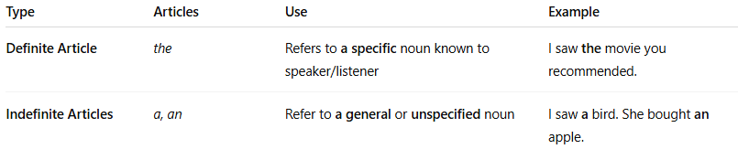
Type | Articles | Use | Example
Definite Article | the | Refers to a specific noun known to speaker/listener | I saw the movie you recommended.
Indefinite Articles | a, an | Refer to a general or unspecified noun | I saw a bird. She bought an apple.

